**Department of Information Systems and Cyber Security University of Texas in San Antonio**



IS 3413: Telecom and Networking-001, Fall, 2022

Name: Daniel Cook  
UTSA ID: dhz799  
Email address: *danielwcook5@gmail.com*

Lab Assignment: Lab: M03 – Signal Coding  
Date Due: 9/17/2022  
Date Submitted: 9/15/2022

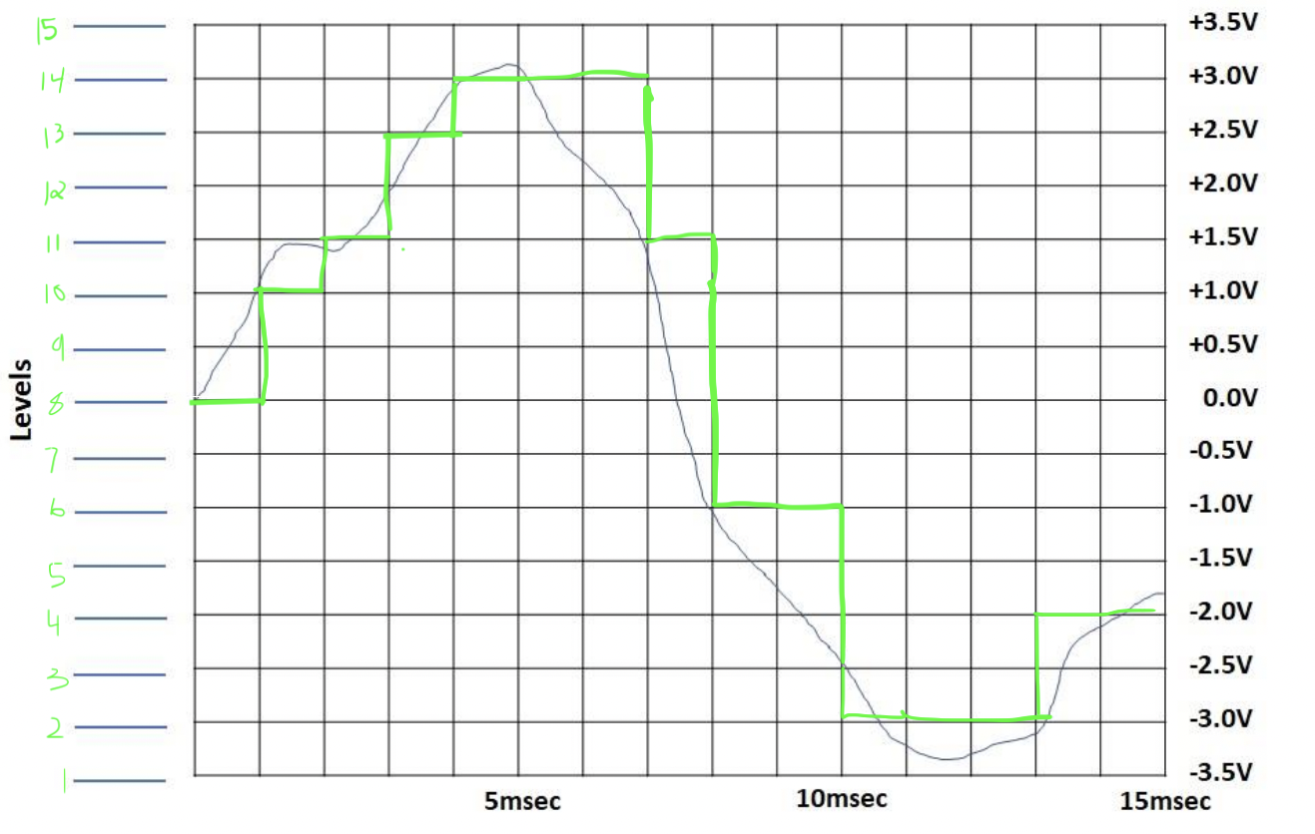

Section A, Question 1: **How many different voltage levels must be represented?**

Voltage range = 3.5- (3.5) = 7V

Interval size = 0.5V

7/0.5 = 14 intervals + 1 (Base level) = 15 levels

Section A, Question 2: **How many bits are needed to represent at least this many levels (i.e., if the answer to question 1 is N, then you must find x, such that 2𝑥𝑥 ≥ 𝑁𝑁)?**

2x = 15

$$\log_{2}{}2^{x}$$ = $$\log_{2}{}15$$

x ~ 4 bits

Section A, Question 4:

|  |  |
| --- | --- |
| -3.5V = | 0000 |
| -3.0V = | 0001 |
| -2.5V = | 0010 |
| -2.0V = | 0011 |
| -1.5V = | 0100 |
| -1.0V = | 0101 |
| -0.5V = | 0110 |
| 0.0V = | 0111 |
| 0.5V = | 1000 |
| 1.0V = | 1001 |
| 1.5V = | 1010 |
| 2.0V = | 1011 |
| 2.5V = | 1100 |
| 3.0V = | 1101 |
| 3.5V = | 1110 |